EXPT NO: 10 | TRANSFORMER-BASED LLM CHATBOT USING STREAMLIT OR GRADIO
DATE: 02-11-26 | TRANSFORMER-BASED LLM CHATBOT USING STREAMLIT OR GRADIO

PRE-LAB QUESTIONS

1. Explain the basic architecture of a Transformer-based LLM.

A Transformer-based LLM is a deep learning model used to understand and generate human language. It consists of encoder and decoder blocks or decoder-only architecture depending on the model. It uses self-attention mechanisms to understand relationships between words in a sentence. Positional encoding helps the model understand the order of tokens. Multiple neural network layers process the input and generate meaningful text.

2. What is the role of tokenization in LLM response generation?

Tokenization is the process of converting input text into smaller units called tokens. These tokens may represent words, subwords or individual characters. The tokenizer converts the tokens into numerical IDs that the LLM can understand. The model processes these numerical IDs to understand the user's input. Finally, the generated token IDs are converted back into readable text.

3. Explain how a pre-trained LLM generates responses to user queries.

A pre-trained LLM is a model trained on a large amount of text data. When a user enters a query, the tokenizer converts the text into numerical tokens. The model processes these tokens using Transformer layers and predicts the next token. This process continues repeatedly until the response is completed or the maximum output length is reached. The generated tokens are converted into readable text and displayed to the user.

4. Differentiate between Streamlit and Gradio.

Streamlit is a Python framework mainly used to create interactive data science and machine learning applications. Gradio is a Python framework designed to build simple interfaces for machine learning models. Streamlit provides components such as buttons, charts, tables and input fields. Gradio provides ready-made components such as textboxes, chat interfaces and image inputs. Both frameworks allow developers to create and share web applications without extensive frontend coding.

5. State the purpose of temperature and maximum output length in text generation.

Temperature controls the randomness of the text generated by an LLM. A low temperature produces more predictable and focused responses. A high temperature produces more creative and varied responses. Maximum output length controls the maximum number of tokens generated by the model. These parameters help control the creativity, length and quality of generated responses.

AIM
To develop an interactive chatbot using a pre-trained Transformer-based LLM and deploy it using Streamlit or Gradio.

SOFTWARE REQUIREMENTS
- Python
- TensorFlow / Keras / PyTorch
- Google Colab
- GitHub
- Hugging Face Transformers
- PyTorch
- Streamlit or Gradio

OBJECTIVES
Students will be able to:
- Understand the working of Transformer-based LLMs.
- Load and configure a pre-trained LLM.
- Generate responses using user prompts.
- Develop an interactive chatbot using Streamlit or Gradio.
- Test and deploy the application.

PROCEDURE
PART A: LOADING AND CONFIGURING A PRE-TRAINED LLM
Perform the following tasks:
- Select a suitable pre-trained LLM using Hugging Face Transformers.
- Load the model and its tokenizer.
- Prepare and tokenize sample user prompts.
- Generate responses by configuring suitable parameters, such as temperature and maximum output length.
- Display and examine the generated responses.

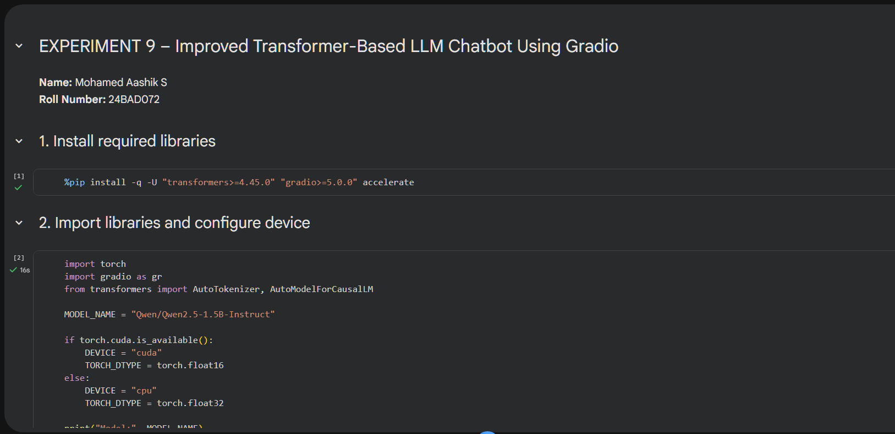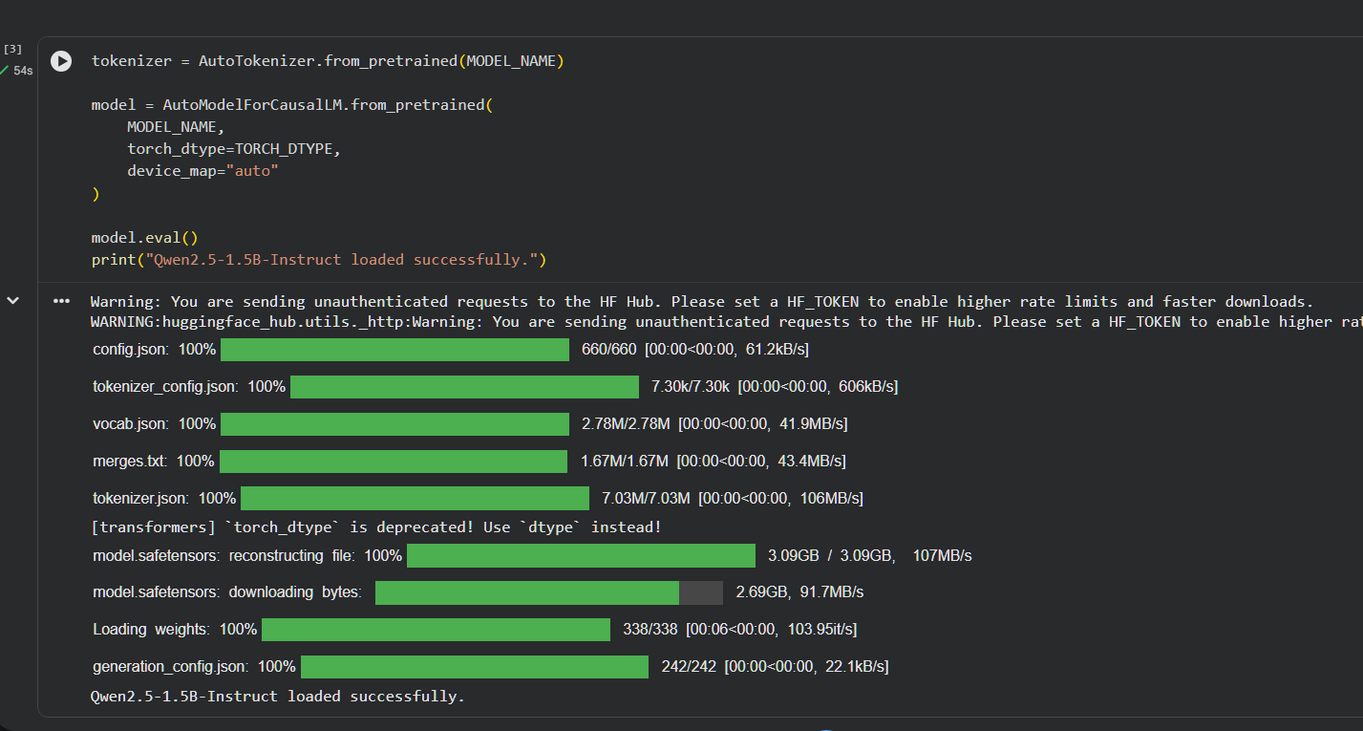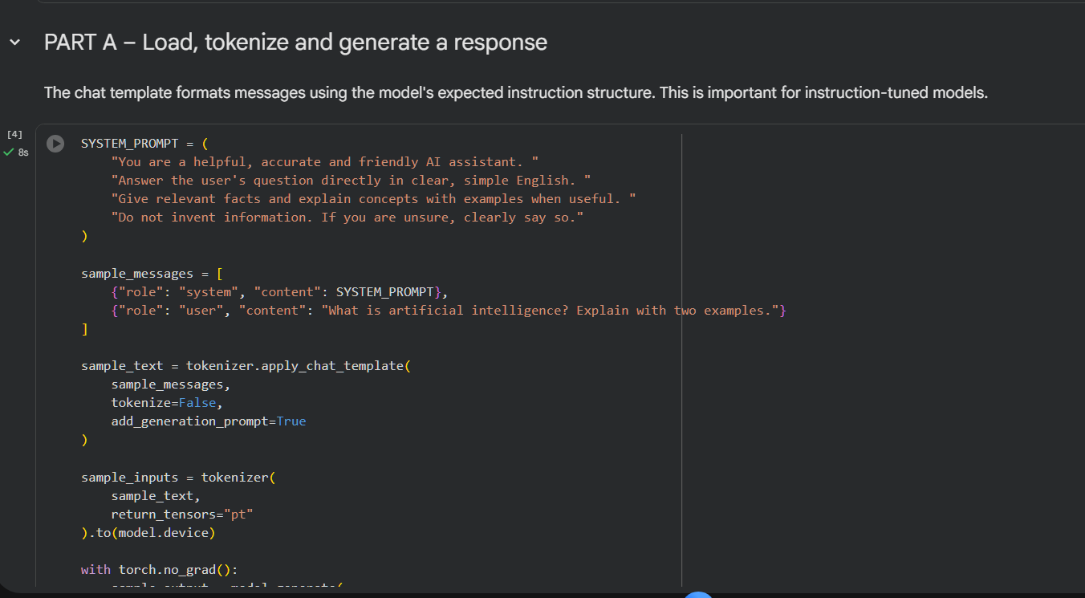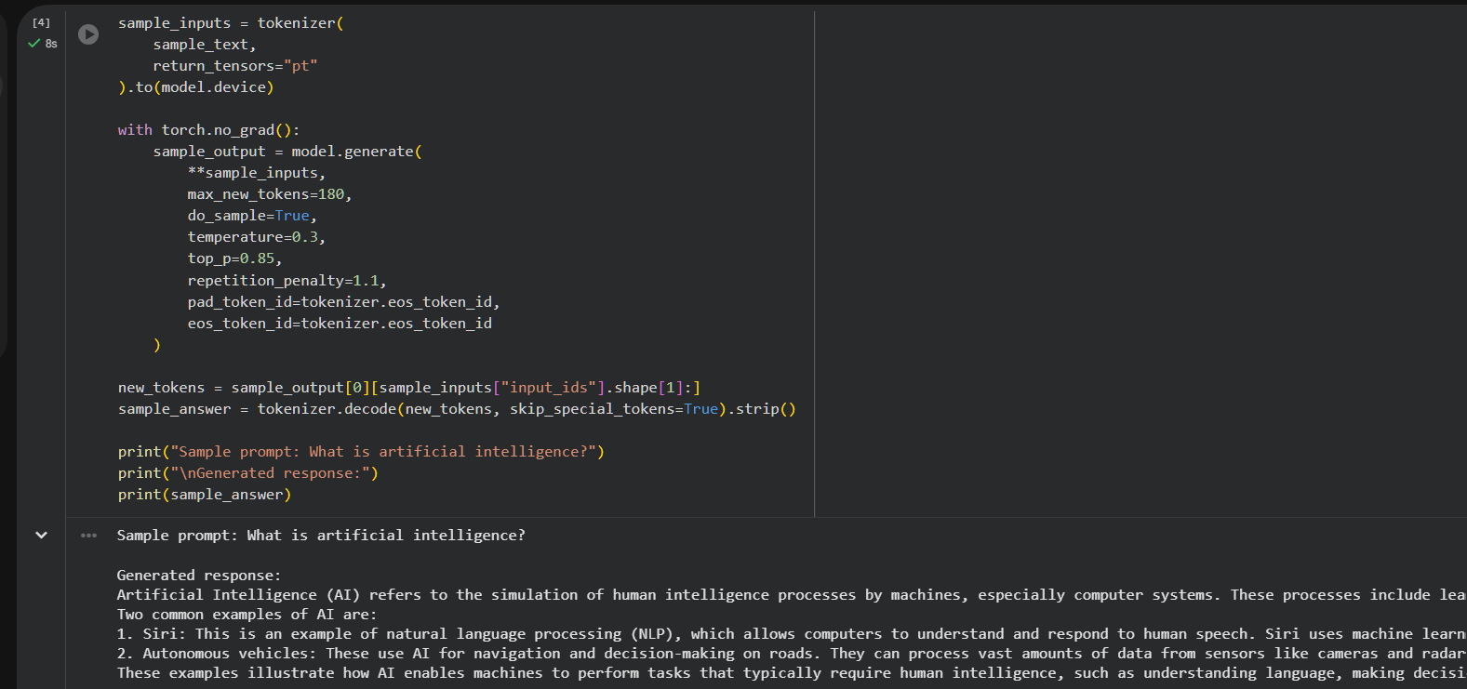

PART B: IMPLEMENTING CHATBOT FUNCTIONALITY

Perform the following tasks:
- Create a function to accept user queries and generate responses using the loaded LLM.
- Construct suitable prompts and display the generated responses.
- Maintain conversation history, if supported by the model.
- Test the chatbot with different queries and observe response quality.

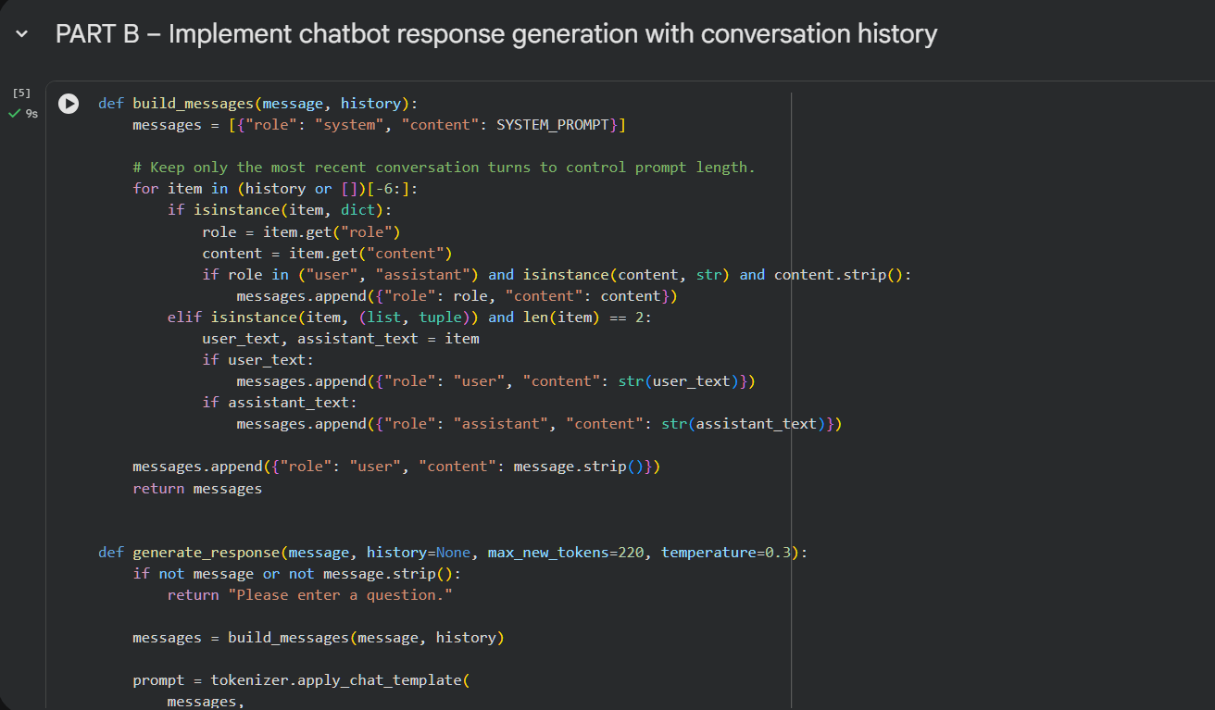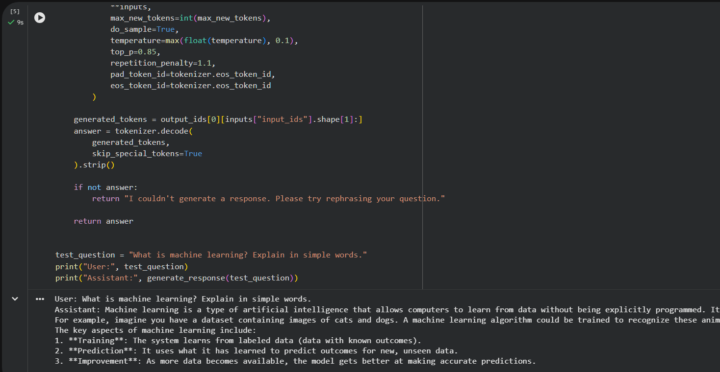

PART C: DEVELOPING AN INTERACTIVE INTERFACE

Perform the following tasks:
- Select Streamlit or Gradio to develop the chatbot interface.
- Create a text input component and a submission mechanism.
- Connect the interface to the LLM response-generation function.
- Display responses in a chat-style layout.
- Run and test the application with different user inputs.
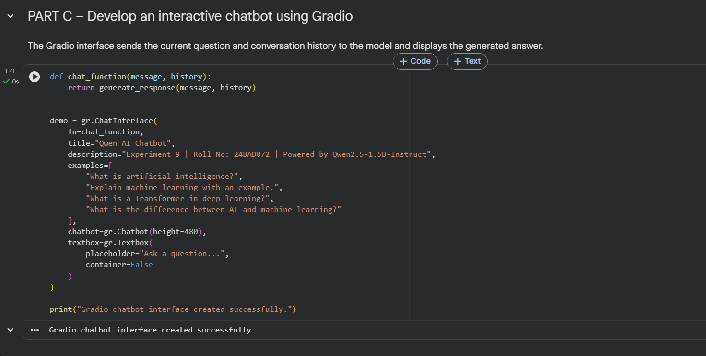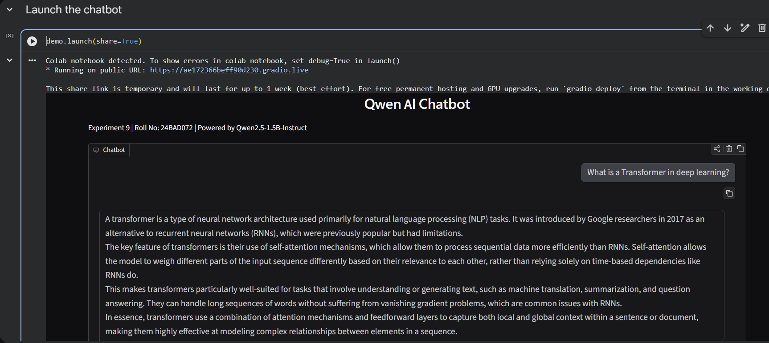

PART D: APPLICATION TESTING AND DEPLOYMENT

Perform the following tasks:
- Test the chatbot for response quality and usability.
- Observe limitations such as hallucinations and response latency.
- Organize the source code and create a requirements.txt file.
- Upload the project to GitHub.
- Deploy the application using a suitable platform, such as Hugging Face Spaces, if available.
- Document the results and limitations.
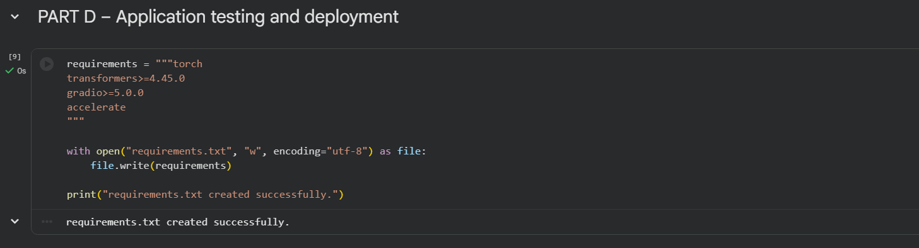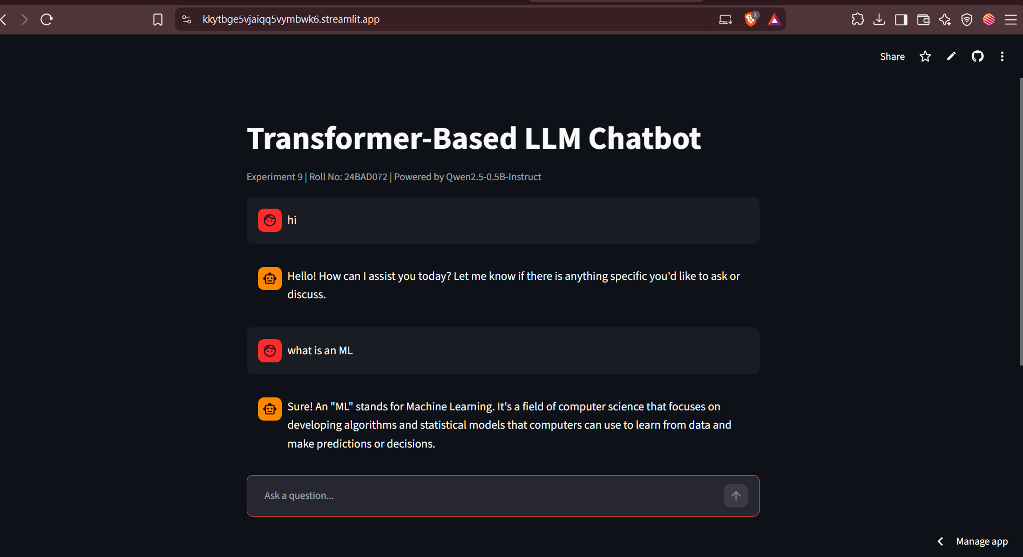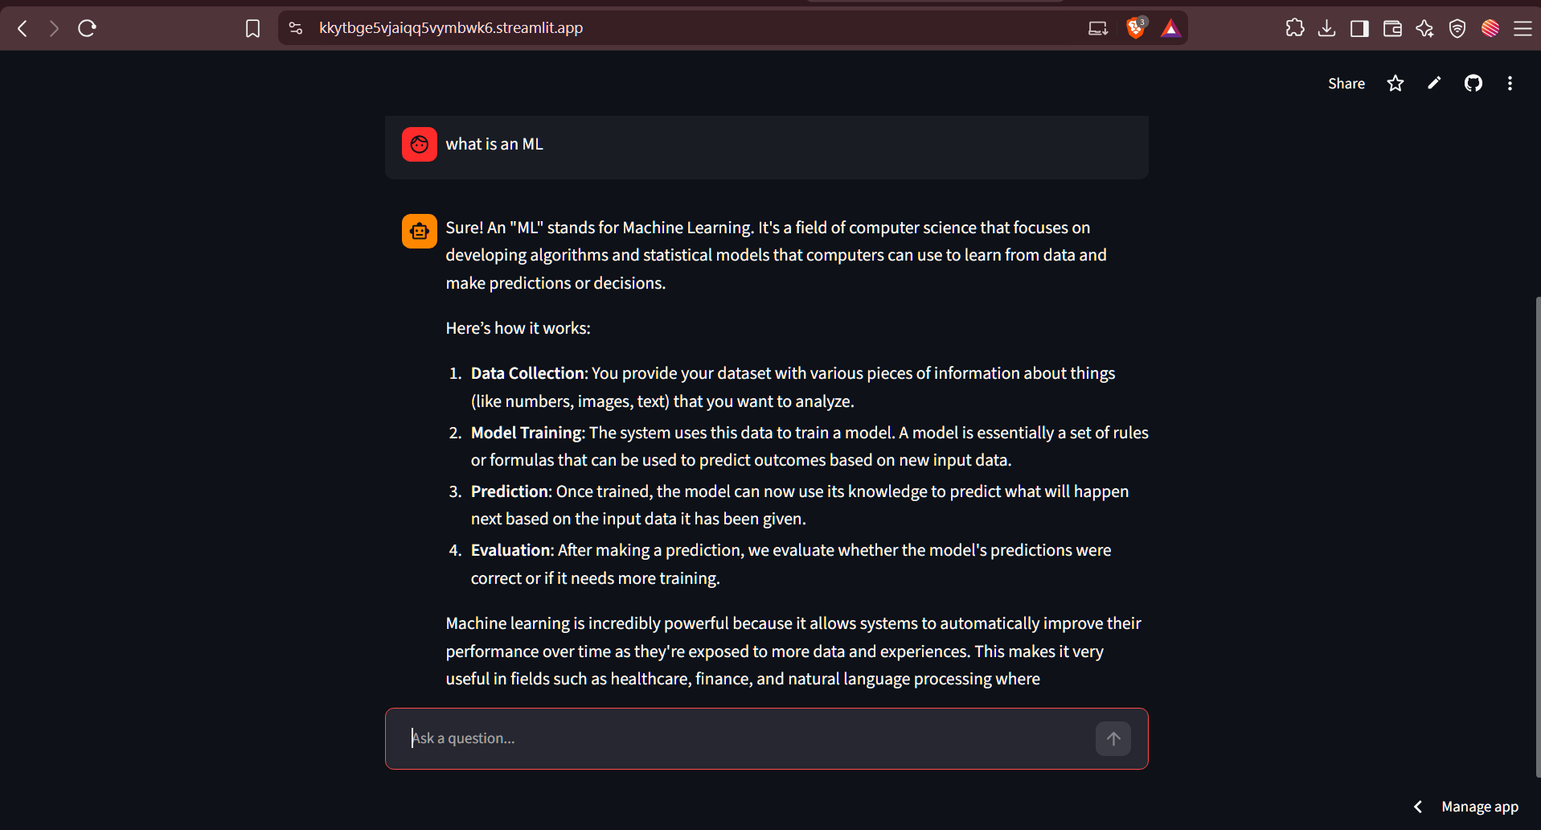

1. Results
The Transformer-based LLM chatbot was successfully developed using the Qwen2.5-1.5B-Instruct pre-trained model from Hugging Face. The model was integrated using the Hugging Face Transformers library to process user prompts and generate meaningful responses. A chatbot interface was developed using Streamlit, allowing users to enter questions and receive AI-generated responses interactively. The application was tested with different queries related to Artificial Intelligence, Machine Learning, Deep Learning and Transformer architectures. The chatbot was able to generate relevant responses and maintain conversation context using conversation history. Finally, the application was successfully deployed using Streamlit, making it accessible through a web browser.
2. Limitations
- Hallucination: The chatbot may sometimes generate incorrect, misleading or unrelated information.
- Limited Knowledge: The model has a fixed training knowledge base and cannot automatically provide real-time information from the internet.
- Computational Requirements: Running the 1.5-billion-parameter model requires sufficient RAM and processing power, especially during model loading and response generation.
- Response Latency: Generating responses may take more time when running on CPU or when the hosting platform has limited computational resources.
- Context Limitations: The chatbot can process only a limited amount of conversation history due to the model's context window.
- Accuracy: The quality and accuracy of generated responses depend on the model's training data and the clarity of user prompts.
3. Overall Conclusion
The experiment successfully demonstrated the development and deployment of an interactive chatbot using a pre-trained Transformer-based LLM. The integration of Hugging Face Transformers with Streamlit provided a simple interface for interacting with the language model. The chatbot demonstrated the ability to understand user prompts and generate context-aware responses. Thus, the objectives of loading a pre-trained LLM, generating responses, developing an interactive interface and deploying the application were achieved.

POST-LAB QUESTIONS

1. Explain how an LLM generates responses from user prompts.

An LLM receives the user's prompt as input and converts it into tokens using a tokenizer. These tokens are processed through Transformer layers using self-attention mechanisms. The model predicts the most suitable next token based on the given context. It continues generating tokens until the response is completed or the output limit is reached. Finally, the generated tokens are converted into readable text and displayed to the user.

2. What is the importance of conversation history in a chatbot?

Conversation history stores the previous messages exchanged between the user and the chatbot. It helps the chatbot understand the context of the current conversation. It allows the chatbot to provide relevant answers based on previous questions and responses. It also helps maintain continuity during multiple interactions. Without conversation history, the chatbot may treat every query as a completely new conversation.

3. Explain the effect of temperature on response generation.

Temperature controls the randomness and creativity of an LLM's responses. A low temperature produces more consistent and predictable answers. A high temperature increases randomness and generates more diverse responses. Very high temperature may produce irrelevant or less accurate answers. Therefore, selecting a suitable temperature improves the quality of chatbot responses.

4. Differentiate between local execution and cloud deployment.

Local execution means running the chatbot directly on a personal computer or local system. It uses the computer's available CPU, GPU and memory resources. Cloud deployment means hosting the chatbot on an online server or cloud platform. It allows users to access the chatbot through the internet without running it on their own computers. Local execution provides more control, while cloud deployment offers easier accessibility and sharing.

5. State two limitations of LLM-based chatbots.

One limitation of LLM-based chatbots is hallucination, where the model generates incorrect or misleading information. Another limitation is high computational requirements, especially when running large models. They may also produce biased responses because of their training data. Some models have limited knowledge of recent events. Therefore, their responses should be verified when accuracy is important.

ASSESSMENT
Description | Max Marks | Marks Awarded
Pre Lab Exercise | 5
In Lab Exercise | 10
Post Lab Exercise | 5
Viva | 10
Total | 30
Faculty Signature

